Stonecorner Mission Statement  “Stonecorner Real Estate and Development is committed to meeting the needs of residents, clients, developers, and investors in the affordable housing industry by providing full-service solutions and implementing creative and result oriented strategies in order to achieve optimal results for all populations and property types.” |  | Miracle Point Apartments  Office Hours:  Monday - Friday  8:00am – 5:00pm  Saturday & Sunday:  Closed
 |  | 375 W Blacklidge Drive Tucson, Arizona 85705  —  Phone: (520) 207 - 6934  —  Fax: (520) 347 - 2995  —  www.stonecorner.org |  | Miracle Point Apartments  Affordable Housing for Chronically homeless (Veteran’s Preference)
 |  |  |  | 

Miracle Point Apartments  Miracle Point Apartments is a new construction community featuring 40 units to serve chronically homeless persons in Tucson with a preference to house veterans. The community features 34 one-bedroom units and 6 two-bedroom units. The project targets incomes at 30% of the area median income. The units feature design elements that follow the Housing First Model and supportive services. Miracle Point is also located close to bus routes, shopping, restaurants and only three miles to downtown Tucson and the Light Rail system.  All utilities are included! Supportive Services are provided by La Frontera Center. Inc. |  | Community Amenities  The Miracle Point property offers on-site supportive services, resident activities, life skills training, job training, financial literacy classes, and computer training. There is also a food pantry available to residents. Miracle Point is a smoke-free community.  Apartment Amenities  The recently built single-story units at Miracle Point have a front and back patio for relaxing in the warm Arizona weather. All utilities are included with your rental payment. The apartment comes with a washer/dryer, ceiling fans, appliances, window coverings and large closets with built-in shelving. The flooring throughout is vinyl with the exception of the carpeted bedroom(s) for your comfort.  Pet Policy  Two small cats or dogs per unit are permitted at Miracle Point Apartments. Your pet(s) must be 25 lbs. or under full grown, and you must provide a $200 refundable pet deposit, and sign a pet addendum. See the community manager for further details.  Services and Amenities:  - NON-SMOKING  - On Bus Line  - All Utilities Included!  - Semi-Furnished  - All appliances, including microwave, provided!  - In unit washer and dryers!  - Private back yard  - On-Site Food Pantry  - On-Site Supportive Services Office  - 24 Hour Emergency Maintenance |  | Unit Information  One Bedroom / One bath  Bed(s):  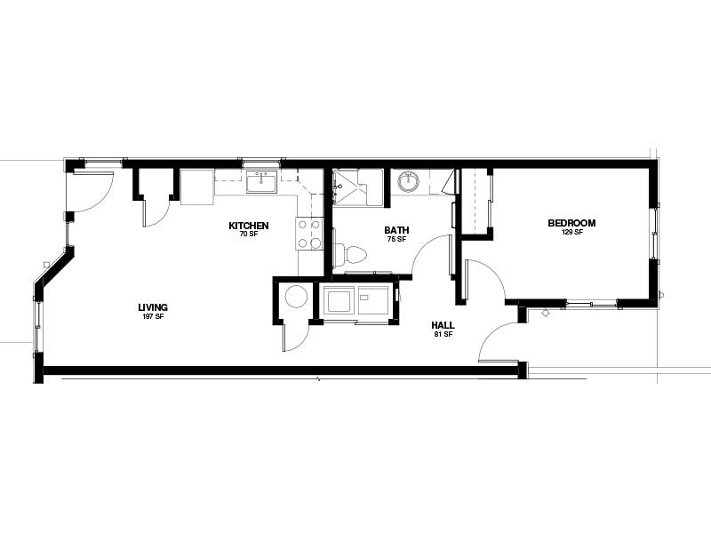  1  Bath(s):  1.0  Sq. Ft.:  660 sq. ft.  Rent:  $385  Two Bedroom / One bath  Bed(s):  2  Bath(s):  1.0  Sq. Ft.:  1160 sq. ft.  Rent:  $463  Leasing Terms:  A twelve-month lease agreement is required at Miracle Point Apartments.

